**Mukesh Patel School of Technology Management and Engineering**



**Guidelines for preparation of Thesis / Dissertations / Reports\***

### for

**B. Tech (Computer Engineering)**

* (Acknowledgement: Formatting guidelines of Indian Institute of Technology, Mumbai are referred)

## Guidelines for preparation of Thesis / Dissertations / Project Reports

### Preamble:

The content of the Thesis/Dissertation/Project report (hereinafter called as report) must be paid utmost attention, which is being submitted in partial fulfillment of the requirements of the Under-graduation in Computer Engineering degree of NMIMS University. A Standard format is equally important and may be prescribed by the Computer Engineering Department, which helps in bringing uniformity in all the reports and improves aesthetics of report. The same format shall also be followed in preparation of the final soft copies to be submitted to the library.

## Organization of the Thesis/Dissertation/ Project report

This report shall be presented in a number of chapters, starting with **Introduction** and ending with **Conclusion**. It shall be ensured that all the chapters will have a precise title reflecting the contents of the chapter. A chapter can be subdivided into sections, sub-sections and so on as to present the content discretely and with due emphasis.

Following must be the sequences of the pages and chapters. Kindly note that, you should not change the sequence and nomenclature of the chapters.

1. Title Page
2. Declaration Page for academic honesty and integrity
3. Certificate page
4. Abstract
5. List of Tables
6. List of figures
7. Abbreviations
8. Chapter 1 – Introduction
9. Chapter 2 – Review of literature
10. Chapter 3 – Analysis and Design
11. Chapter 4 – Implementation
12. Chapter 5 – Conclusion and Future Work
13. References (Must not hold chapter number)
14. Publications (Must not hold chapter number)
15. Acknowledgement

### Introduction:

The title of Chapter 1 shall be Introduction. It shall justify and highlight the problem posed, define the topic and explain the aim and scope of the work presented in the report. It may also highlight the significant contributions from the investigation.

*The Introduction tells the reader what the report is about. It sets the project in its wider context, and provides the background information the reader needs to understand the report.*

*The Introduction:*

* *Introduces the topic of the report in context*
* *Explains the problem and/or motivation for the project*
* *States the aim/s of the project*
* *Indicates the purpose of the report*
* *Briefly outlines the report structure (not necessary in a short report).*

### Review of Literature:

This shall normally form Chapter 2 and shall present a critical appraisal of the previous work published in the literature pertaining to the topic of the investigation. The extent and emphasis of the chapter shall depend on the nature of the investigation.

*A literature review is a critical analysis of published sources, or literature, on a particular topic. It is an assessment of the literature and provides a summary, classification, comparison and evaluation. At postgraduate level literature reviews can be incorporated into an article, a research report or thesis. At undergraduate level literature reviews can be a separate standalone assessment.*

*The literature review is generally in the format of a standard essay made up of three components: an introduction, a body and a conclusion. It is not a list like an annotated bibliography in which a summary of each sources are listed one by one.*

***Why do we write literature reviews?***

*At university you may be asked to write a literature review in order to demonstrate your understanding of the literature on a particular topic. You show your understanding by analysing and then synthesising the information to:*

* *Determine what has already been written on a topic*
* *Provide an overview of key concepts*
* *Identify major relationships or patterns*
* *Identify strengths and weaknesses*
* *Identify any gaps in the research*
* *Identify any conflicting evidence*
* *Provide a solid background to a research paper’s investigation*

***How to write a literature review?***

* ***Determine your purpose***

*Work out what you need to address in the literature review. What are you being asked to do in your literature review? What are you searching the literature to discover? Check your assignment question and your criteria sheet to know what to focus on.*

* ***Do an extensive search of the literature?***

*Find out what has been written on the topic.*

* ***What kind of literature?***

*Select appropriate source material: Use a variety of academic or scholarly sources that are relevant, current and authoritative. An extensive review of relevant material will include — books, journal articles, reports, government documents, conference proceedings and web resources. The Library would be the best place to search for your sources.*

* ***How many resources?***

*The number of sources that you will be required to review will depend on what the literature review is for and how advanced you are in your studies. It could be from five sources at first year undergraduate level to more than fifty for a thesis. Your lecturer will advise you on these details.*

### Design and Implementation:

The reporting on the investigation shall be presented in one or more chapters with appropriate chapter titles.

* + - Due importance shall be given to experimental setups, procedures adopted, techniques developed, methodologies developed and adopted.
    - While important derivations/formulae should normally be presented in the text of these chapters, extensive and long treatments, copious details and tedious information, detailed results in tabular and graphical forms may be presented in Appendices. Representative data in table and figures may, however, be included in appropriate chapters.
    - Figures and tables should be presented immediately following their first mention in the text. Short tables and figures (say, less than half the writing area of the page) should be presented within the text, while large table and figures may be presented on separate pages.
    - Equations should form separate lines with appropriate paragraph separation above and below the equation line, with equation numbers flushed to the right.
    - System Block Diagram (Architecture diagram) with description of all the modules is required.
    - E-R diagram is only applicable if the project contains database.
    - The Design part must also consist of UML diagrams (Whichever applicable) with the description of each diagram. Following UML diagrams can be considered.
      * Use Case Diagrams
      * Activity Diagrams
      * Class Diagram
      * Sequence Diagram

### Results and Discussion:

This shall form the penultimate chapter of the report and shall include a thorough evaluation of the investigation carried out and bring out the contributions from the study. The discussion shall logically lead to inferences and conclusions as well as scope for possible further future work.

### Conclusion and Future Work:

This will be the final chapter of the report. A brief report of the work carried out shall form the first part of the Chapter. Conclusions derived from the logical analysis presented in the Results and Discussions Chapter shall be presented and clearly enumerated, each point stated separately. Scope for future work should be stated lucidly in the last part of the chapter.

***Introductions and conclusions*** *can be difficult to write, but they’re worth investing time in. They can have a significant influence on a reader’s experience of your paper*

***Your conclusion*** *is your chance to have the last word on the subject. The conclusion allows you to have the final say on the issues you have raised in your paper, to synthesize your thoughts, to demonstrate the importance of your ideas, and to propel your reader to a new view of the subject. It is also your opportunity to make a good final impression and to end on a positive note.*

***Your conclusion*** *can go beyond the confines of the assignment. The conclusion pushes beyond the boundaries of the prompt and allows you to consider broader issues, make new connections, and elaborate on the significance of your findings.*

***Your conclusion should*** *make your readers glad they read your paper. Your conclusion gives your reader something to take away that will help them see things differently or appreciate your topic in personally relevant ways. It can suggest broader implications that will not only interest your reader, but also enrich your reader’s life in some way. It is your gift to the reader.*

***Strategies for writing an effective conclusion***

***One or more of the following strategies may help you write an effective conclusion:***

* ***Play the “So What” Game.****If you’re stuck and feel like your conclusion isn’t saying anything new or interesting, ask a friend to read it with you. Whenever you make a statement from your conclusion, ask the friend to say, “So what?” or “Why should anybody care?” Then ponder that question and answer it. Here’s how it might go: You: Basically, I’m just saying that education was important to Douglass. Friend: So what? You: Well, it was important because it was a key to him feeling like a free and equal citizen. Friend: Why should anybody care? You: That’s important because plantation owners tried to keep slaves from being educated so that they could maintain control. When Douglass obtained an education, he undermined that control personally. You can also use this strategy on your own, asking yourself “So What?” as you develop your ideas or your draft.*
* ***Return to the theme or themes in the introduction.****This strategy brings the reader full circle. For example, if you begin by describing a scenario, you can end with the same scenario as proof that your essay is helpful in creating a new understanding. You may also refer to the introductory paragraph by using key words or parallel concepts and images that you also used in the introduction.*
* ***Synthesize, don’t summarize.****Include a brief summary of the paper’s main points, but don’t simply repeat things that were in your paper. Instead, show your reader how the points you made and the support and examples you used fit together. Pull it all together.*
* ***Include a provocative insight or quotation from the research or reading you did for your paper.***
* ***Propose a course of action, a solution to an issue, or questions for further study.****This can redirect your reader’s thought process and help her to apply your info and ideas to her own life or to see the broader implications.*
* ***Point to broader implications.****For example, if your paper examines the Greensboro sit-ins or another event in the Civil Rights Movement, you could point out its impact on the Civil Rights Movement as a whole. A paper about the style of writer Virginia Woolf could point to her influence on other writers or on later feminists.*

### Appendix:

Detailed information, lengthy derivations, raw experimental observations etc. are to be presented in the separate appendices, which shall be numbered in Roman Capitals (e.g. “Appendix I”). Since reference can be drawn to published/unpublished literature in the appendices these should precede the “Literature Cited” section.

### Literature Cited (References – APA Style Only):

This should follow the Appendices, if any, otherwise the Conclusions chapter. The candidates shall follow the style of citation and style of listing in one of the standard journals in the subject area consistently throughout his/her report, for example, IEEE in the Department of Electrical Engineering, ASME in Department of Mechanical Engineering. However, the names of all the authors along with their initials and the full title of the article/monogram/book etc. have to be given in addition to the journals/publishers, volume, number, pages(s) and year of publication.

References **are not supposed to be hardcoded**, they have to be taken from Google scholar. Refer the procedure for citing references from google scholar.

*Google scholar provides citations for articles from the search result list (currently MLA, APA, Chicago, Harvard or Vancouver).*

1. *Open Google Scholar website,* [*https://scholar.google.com/*](https://scholar.google.com/)
2. *Search the paper with exact title.*
3. *Click on ” link below the paper title as shown in the figure.*

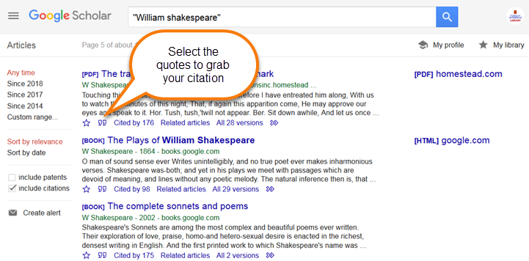

1. *You can see various styles of references (APA, MLA, Chicago etc) appeared on a box. Use* ***APA Style of referencing as shown in the figure.***

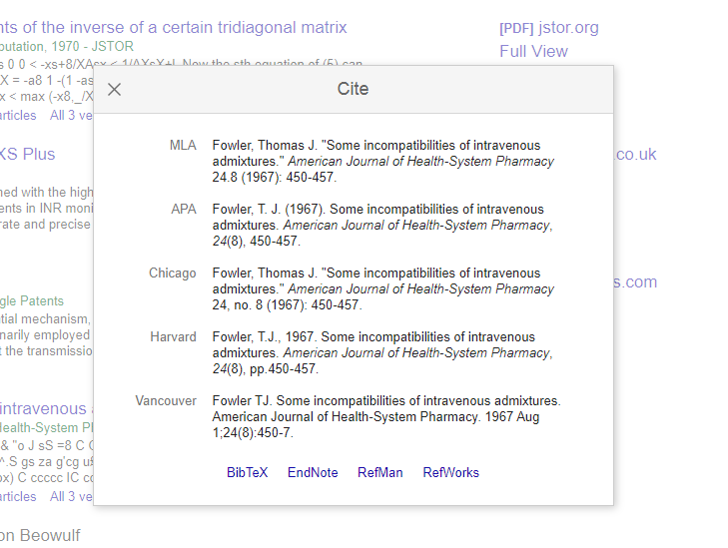

1. *Change the font to match the font of your paper.*

**Citation from websites** should include the names(s) of author(s) (including the initials), full title of the article, website reference and when last accessed. Reference to personal communications, similarly, shall include the author, title of the communication (if any) and date of receipt.

#### 1.7.1 Publications by the candidate:

Articles, technical notes etc. on the topic of the report published by the candidate may be separately listed after the literature cited. This may also be included in the contents. The candidates may also include reprints of his/her publications after the literature citation.

### Acknowledgements:

The acknowledgments by the candidate shall follow the citation of literature, signed by him/her, with date.

## Thesis/Dissertations/Project Reports Format

### Paper:

The front pages of the report shall be printed on white bond paper, whiteness 95% or above, weight 70 gram or more per square meter. The size of the paper shall be standard A4; height 297 mm, width 210 mm.

The rest pages of the report can be printed on normal white paper.

### Type Setting, Text Processing and Printing:

The text shall be printed on single side of a page employing laser jet or Inkjet printer, the text having been processed using a standard text processor. The standard font shall be **Times New Roman** of **12 pts** with **1.5-line spacing**.

#### Page Format:

The Printed Sheets shall have the following written area and margins:

|  |  |
| --- | --- |
| Top Margin : | 15 mm |
| Head Height : | 3 mm |
| Head Separation : | 12 mm |
| Bottom Margin : | 22 mm |
| Footer : | 3 mm |
| Foot Separation : | 10 mm | |
| Left Margin : | 30 mm |
| Right Margin : | 20 mm |
| Text Height | 245 mm |
| Text Width | 160 mm |

When header is not used the top margin shall be 30 mm.

#### Pagination:

Page numbering in the text of the report shall be Hindu- Arabic numerals at the center of the footer. Page number “1” for the first page of the Introduction chapter shall not appear in print; only the second page will bear the number “2”. The subsequent chapters shall begin on a fresh

page. Pagination for pages before the Introduction chapter shall be in lower case Roman numerals, e.g., “iv”.

#### Header:

When the header style is chosen, the header can have the Chapter number and Section number (e.g., Chapter 2, Section 3) on even numbered page headers and Chapter title or Section title on the odd numbered page header.

#### Paragraph format:

Vertical space between paragraphs shall be about 2.5 line spacing. The first line of each paragraph should normally be indented by five characters or 12mm. A candidate may, however, choose not to indent if s/he has provided sufficient paragraph separation. A paragraph should normally comprise more than one line. A single line of a paragraph shall not be left at the top or bottom of a page. The word at the right end of the first line of a page or paragraph should, as far as possible, not be hyphenated.

### Chapter and Section Format:

#### Chapter:

Each chapter shall begin on a fresh page with an additional top margin of about 75mm. Chapter number and title shall be printed at the center of the line in 6mm font size (18pt) in bold face using both upper and lower case (all capitals or small capitals shall not be used). A vertical gap of about 12 mm (spacing after font size 36 with single line spacing) shall be left between the Chapter number and Chapter title lines and between chapter title line and the first paragraph (sample is given as specimen „E‟).

#### Sections and Sub-sections:

A chapter can be divided into Sections, Sub-sections and Sub-sub Sections so as to present different concepts separately. Sections and sub-sections can be numbered using decimal points, e.g. 2.2 for the second section in Chapter 2 and 2.3.4 for the fourth Sub-section in third Section of Chapter 2. Chapters, Sections and Subsections shall be included in the contents with page numbers flushed to the right. Further subsections need not be numbered or included in the contents.

The Section and Sub • Section titles along with their numbers in 5 and 4mm (16 and 14 pt) fonts, respectively, in bold face shall be flushed to the left (not centered) with 15 mm space

above and below these lines.

In further subdivisions character size of 3 and 3.5 with bold face, small caps, all caps and italics may be used for the titles flushed left or centered. These shall not feature in the contents.

#### Table / Figure Format:

Tables and figures should be presented in portrait style as far as possible. Small size table and figures (less than half of writing area of a page) should be incorporated within the text, while larger ones may be presented on separate pages. Table and figures shall be numbered chapter •wise. For example, the fourth figure in chapter 5 will bear the number Figure 5.4 or Fig 5.4.

Table number and title will be placed above the table while the figure number and caption will be located below the figure. Reference for Table and Figures reproduced from elsewhere shall be cited in the last and separate line in the table and figure caption.

## Auxiliary Format

### Binding:

The final hard bound copies to be submitted after the viva-voce examination will be accepted during the submission of thesis/dissertation/ project report with black color.

### Front Covers:

The front covers shall contain the following details:

* + - Full title of thesis in 6 mm 22 point's size font properly centered and positioned at the top.
    - Full name of the candidate in 4.5 mm 15 point's size font properly centered at the middle of the page.
    - A 50 mm dia replica of the Institute emblem followed by the name of department, name of the Institute and the year of submission, each in a separate line and properly centered and located at the bottom of page.

#### Lettering:

All lettering shall be embossed in gold.

* + 1. **Bound back:**

The degree, the name of the candidate and the year of submission shall also be embossed on the bound (side) in gold.

### Blank Sheets:

In addition to the white sheets (binding requirement) two white sheets shall be put at the beginning and the end of the thesis.

### Title Sheet and Cover Sheet:

This shall be the first printed page of the report and shall contain the submission statement: the Thesis/Dissertation/project Report submitted in partial fulfillment of the requirements of the Degree, Ph.D. /M.E./B.E., the name and Roll No. of the candidate, name(s) of the Supervisor and Co-supervisor (s) (if any), Department, Institute and year of submission.

* + - **Sample copy of the 'Title Sheet' is appended (Specimen 'A' is given in a separate Sheet)**

### A Declaration of Academic Honesty and Integrity:

A declaration of Academic honesty and integrity is required to be included along with every thesis/dissertation/ project report after the approval sheet.

* **The format of this declaration is given in Specimen `B' attached.**

### Certificate Page (Internal Approval Sheet)

In the absence of a dedication sheet this will form the first page and in that case shall not have a page number. Otherwise, this will bear the number two in Roman lower case “ii” at the center of the footer.

* **Sample copy of the 'Internal Approval Sheet' is appended (Specimen C)**

### Abstract:

The 400-500-word abstract shall highlight the important features of the thesis/dissertation/ project report and shall correspond to the electronic version to be submitted to the Library for inclusion in the website. The Abstract in the thesis, however, shall have two more parts, namely, the layout of the thesis giving a brief chapter• wise description of the work and the key words.

### Contents, List of Figures and Tables:

The contents shall follow the Abstract and shall enlist the titles of the chapters, section and sub-section using decimal notation, as in the text, with corresponding page number against them, flushed to the right.

Two separate lists of Figure captions and Table titles along with their numbers and corresponding page numbers against them shall follow the Contents.

* + - **Sample copy of the ‘List of Tables and figures’ is appended (Specimen “D”)**

### Abbreviation Notation and Nomenclature:

A complete and comprehensive list of all abbreviations, notations and nomenclature including Greek alphabets with subscripts and superscripts shall be provided after the list of tables and figures. (As far as possible, generally accepted symbols and notation should be used).

Auxiliary page from dedication (if any) to abbreviations shall be numbered using Roman numerals in lower case, while the text starting from the Introduction shall be in Hindu-Arabic. **(The first pages in the both the cases shall not bear a page number).**

* **Specimen E gives Sample format of Black Book Chapters.**